Seminar Questions

What is a correlation analysis and what does a correlation coefficient of r = 0 indicate about the relationship between two variables?

Checks to see if two variables are correlated or related. E.g. if and increase in one variable can be shown to match an increase or decrease in another. A value of 0 is no correlation.
Correlation does not indicate cause!
predictor or explanatory variable and response variable

What is the range of possible values for the Pearson correlation coefficient?
Values can range from -1 to 1. a value of -1 is 1:1 negative correlation and a value of 1 is perfect 1:1 positive correlation.

When should you use Spearman's or Kendall's rank correlation instead of Pearson's correlation?
The pearson correlation works only for normally distributed variables.
Spearman's and Kendall's rank correlation coefficients are to be used when the data is not perfectly, or close to, normal distribution.

What is the use of scatter plot?
Scatter plots can give a quick at-a-glance overview of correlations between data. They can provide a visual aid for identifying trends and give understanding of the data types and distributions.

What does the intercept (β₀) represent in a simple linear regression model?
The response variable when the predictor or explanatory variable is 0
(β₁ ) is the slope
( ε ) is error “residual” error or “random” error aka normal variation

What is the purpose of residuals in linear regression?
Shows the difference between the predicted and recorded values.
“unexplained variation”

Square to account for negative values.

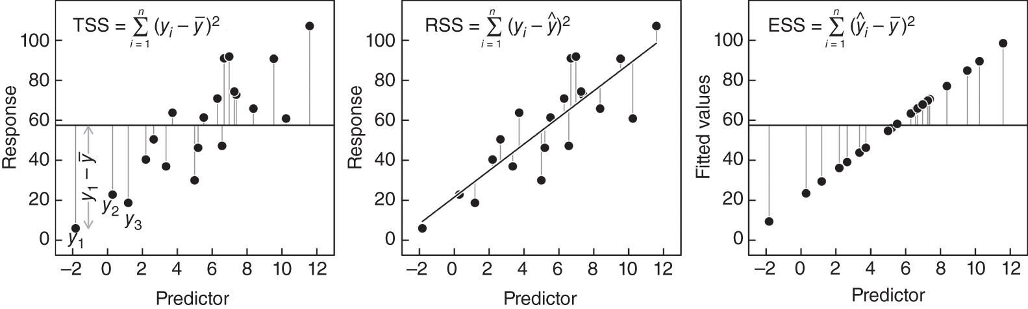

What does an R² value of 0.85 mean in a regression model?
The higher the value of R² the better the fit of the model to the data.
85% suggests that 85% of the variance of leafresp can be explained with temperature

Dataset Activity

Create a new variable called TotalConfirmed (sum of ConfirmedIndianNational and ConfirmedForeignNational).
df_total_confirmed <- df

df_total_confirmed$total_confirmed <- rowSums(
df[, c("ConfirmedIndianNational", "ConfirmedForeignNational")],
na.rm = TRUE
)

df_total_confirmed$ConfirmedIndianNational <- NULL
df_total_confirmed$ConfirmedForeignNational <- NULL
df_total_confirmed$Sno <- NULL

Also did a visual check and a check for normal distribution. Data did not appear to be normally distributed.
# Shapiro–Wilk normality test
#data does not apear to be normally distributed!!
for (col in names(df)) {

if (is.numeric(df[[col]])) {

x <- na.omit(df[[col]])

if (length(x) >= 3 && length(x) <= 5000) {

test <- shapiro.test(x)

if (test$p.value > 0.05) {
cat(
col, ": Normally distributed",
"(W =", round(test$statistic, 5),
", p =", round(test$p.value, 5), ")\n"
)
} else {
cat(
col, ": NOT normally distributed",
"(W =", round(test$statistic, 5),
", p =", round(test$p.value, 5), ")\n"
)
}
}
}
}

#scatter plot observation
pairs.panels(
df_total_confirmed,
method = "kendall", # correlation method
hist.col = "grey", # histogram colour
density = TRUE, # show density curves
ellipses = FALSE, # remove correlation ellipses
scale = TRUE,
cex.cor = 2.5,
main = "Fresh Data Inspection",
pch = 19
)

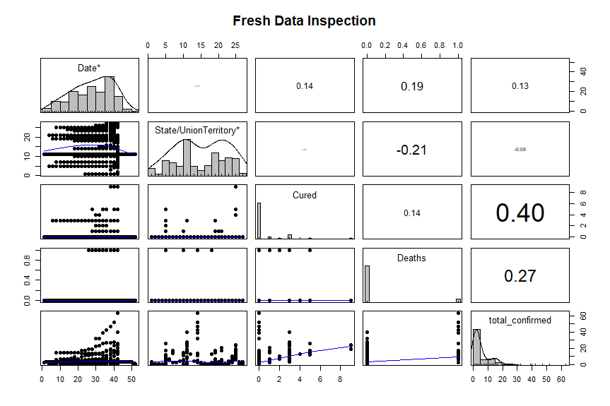

Calculate Pearson correlation coefficients between:
- TotalConfirmed and Cured.
- TotalConfirmed and Deaths.
- Cured and Deaths.

Created variable combine confirmed and removed columns that data was combined from into new data set
#pearson correlation
#Total Confirmed Cured
cor.test(
df_total_confirmed$total_confirmed,
df_total_confirmed$Cured,
method = "pearson"
)

#Total COnfirmed Dead
cor.test(
df_total_confirmed$total_confirmed,
df_total_confirmed$Deaths,
method = "pearson"
)

#Cured and Deaths
cor.test(
df_total_confirmed$Cured,
df_total_confirmed$Deaths,
method = "pearson"
)

Pearson's product-moment correlation

data: df_total_confirmed$total_{c}onfirmedanddf_{t}otal_{c}onfirmed$Cured
t = 6.5614, df = 268, p-value = 2.741e-10
alternative hypothesis: true correlation is not equal to 0
95 percent confidence interval:
0.2643978 0.4705111
sample estimates:
cor
0.3720313

Pearson's product-moment correlation

data: df_total_confirmed$total_{c}onfirmedanddf_{t}otal_{c}onfirmed$Deaths
t = 6.831, df = 268, p-value = 5.647e-11
alternative hypothesis: true correlation is not equal to 0
95 percent confidence interval:
0.2785188 0.4822955
sample estimates:
cor
0.3850911

Pearson's product-moment correlation

data: df_total_confirmed$Curedanddf_{t}otal_{c}onfirmed$Deaths
t = 1.2811, df = 268, p-value = 0.2013
alternative hypothesis: true correlation is not equal to 0
95 percent confidence interval:
-0.04174599 0.19557312
sample estimates:
cor

There appears to be a notable correlation between the number of reported cases and both the number of deaths and the number of cured.

Develop a simple linear regression model to predict the number of deaths based on the total number of confirmed COVID-19 cases. Report and interpret:
- The regression equation (intercept and slope).
- R-squared value and adjusted R-squared.
- Statistical significance of the model (F-statistic and p-value).
- Statistical significance of the predictor (t-value and p-value).

#linear regression
model <- lm(
Deaths ~ total_confirmed,
data = df_total_confirmed
)

summary(model)

coef(model)

Intercept = 0.00747
Slope = 0.01237
That means that when there are 0 reports, the model will still predict around 0.00755 deaths.
For every +1 increase in reported cases, the model predicts around 0.0124 deaths. Or for every +80.645 reported cases, the model expects 1 death.
R² = 0.1483
Meaning that around 14.8% of variation on reported deaths can be predicted by the number of reported cases.
F-statistic: 46.66
Meaning that the model is 46.66 times more accurate explanation of the variable than with no predictor.
p-value: 5.647e-11
This is significantly less that 0.05 or even 0.01, therefore we must reject the null hypothesis.
There is only one predictor therefore the tvalue is:
t = √46.66 ≈ 6.83
And the p value is the same as above.
Conclusion: The number of reported cases appears to have a strong correlation to the number of deaths.

